Unit 3 Study Guide Name ______________________
1. Complete the following table.
Layer Names: | The Crust | The Inner Core | The Outer Core | The Mantle
Temperature | 0-1000° | 4,000-5,000° | 3,000-4,000° | 1,000-3,000°
Density | Lease dense | Most dense | Second Most Dense | Second Least Dense
Composition | Solid rock containing silicon | Solid Iron and Nickel | Liquid Iron and nickel | Molten rock
Thickness | 5-70 km | 1,300 km | 2,200 km | 2,900 km

2. Order the layers from hottest to coldest:
Inner Core, Outer Core, Mantle, Crust
3. Order the layers from thickest to thinnest:
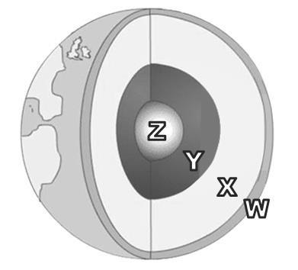
The Mantle, Outer Core, Inner Core, Crust
4. Name the differences between layer W and layer X (seen in the diagram)?
w is thinner, x is hotter, w is solid, x is liquid, w is less dense

5. How does density and temperature change as you move from crust to the core (as you go deeper)?
temperature and density increase

(Circle the word that completes the sentence correctly.)
6. Compared to the earth's outer core, the crust is (more/less) dense and (hotter/cooler).
8. Compared to the outer core, the inner core is (more/less) dense and (hotter/cooler).
7. What keeps the inner core solid even though the temperature is very high?
HIGH PRESSURE
9. The Earth’s mantle is made up of very hot material that rises to the top of the mantle, then sinks, and rises again, repeating the cycle. This action, which causes the Earth’s crust to move, is known as CONVECTION CURRENTS.
11. Convection currents occur in the mantle. Choose the best words to make a statement which best describes the motion of convection currents: Warmer matter (rises/sinks) and is (more/less) dense.

10. List all information which can best completes the center of this venn diagram.

The Inner -solid The Crust
Core -thinner than
-hottest layer the mantle -coolest layer

-made of iron -made of rock

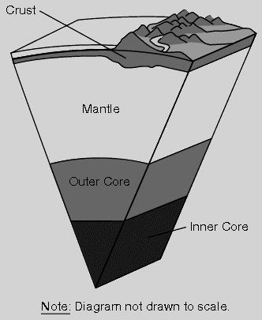
12. Use the diagram to answer the question. In which area of Earth are the tectonic plates located?
crust and upper mantle

13. Weak spots in the crust where magma can flow on the Earth's surface form volcanos.

14. Why is the Atlantic Ocean getting bigger in size, while the Pacific Ocean is shrinking?
the Atlantic ocean has a mid-ocean ridge or divergent boundary which creates more land, and the pacific has convergent boundaries which is destroying land.

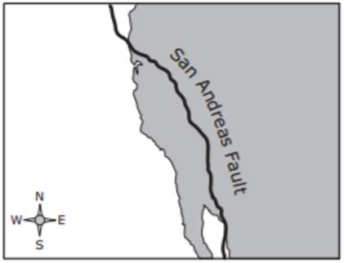
15. The San Andreas fault is a transform fault. Draw arrows on the map showing which way land would most likely move over thousands of years.

16. Rift valleys can form when fractures in Earth’s crust widen. The valley walls slowly move at a rate of only a few millimeters a year. Rift valleys form where two plates move away from each other.

17. Circle which of the following choices most likely would happen when oceanic crust and continental crust collide? (earthquake) (tsunami) (landslide) (volcano)

18. Explain how the Ring of Fire formed.
The plates surrounding the Pacific Ocean are moving toward the Pacific Plate, volcanoes form at the convergent boundaries
19. Circle all of the following which are how tsunamis are created? (underwater earthquake)
(Volcanos in the ocean) (A landslide)

20. When two oceanic plates collide, this forms a convergent boundary. Circle which of the following land forms is created in this process. (Island Arc) (Trench) (Subduction Zone)

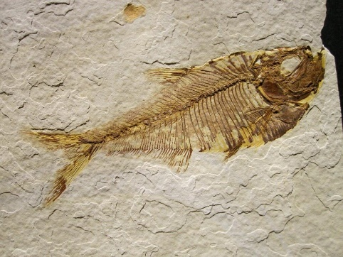
21. A student is studying a fossil of a fish that was found in the desert. Which statement most likely describes why the fossil was found in the desert?
the desert used to be in a climate which allowed a lake or river to be where the desert is now. The continent likely moved.

22. What name is given to the theory that the continents slowly move across the Earth's surface?
Continental drift theory
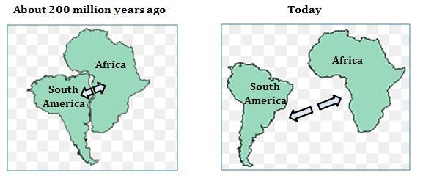
23. Scientist hypothesized that Earth’s continents were once a single landmass that broke apart. The model below shows South America and Africa breaking apart over the last 200 million years. What evidence best supports this model?
fossil evidence

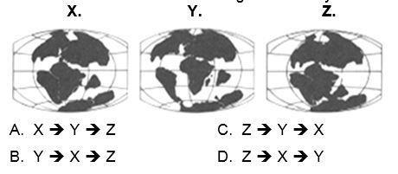
24. These maps illustrate various stages and locations of the world’s continents. Which of the following is the maps in order showing the continents from Pangaea to today?

25. Circle what type of fossil evidence support Wegener’s Continental Drift Theory (Continents moving apart)? (Same/different) dinosaur’s fossils found on (same/different) continents.

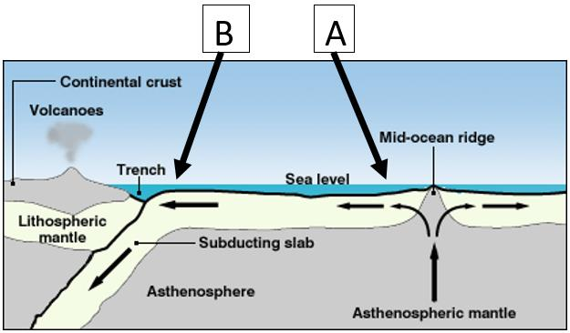
26. Two rock samples were taken from the ocean floor. Rock A was taken close to the mid-ocean ridge.
Rock B was taken 500 miles away from the mid-ocean ridge. Which rock is younger and why?
Rock A is younger because crust is created at a mid-ocean ridge.

27. Corals can only live in warm water. A fossil of a coral was found in the Arctic. How can you explain this?
The Artic used to be in a warm place due to continental drift.
28. Circle the type of evidence was NOT used by Alfred Wegener to support his Continental Drift hypothesis. Evidence from: (landforms) (fossils)
(human remains) (climate)

29. What can fossils reveal about Earth’s past? (circle the correct answer)
A. (Changes in Earth over time) OR (Present Earth)

B. (Earth’s climate) OR (Earth’s surface features) OR (Both Earth’s climate and surface features)

30. Evidence that North America used to be connected to Europe is given by the fact that the following two mountain chains seem to line up if the coastlines of North America and Eurasia are matched up: (Draw a line between the two correct mountain ranges)
North American Mountains: European Mountains:
Rockies - -Caledonides
Appalachians- -Himalayas
-Alps

